Name:_____________________________ Date:______________

Introduction to 3D Figures

Shape Net # of Faces # of Edges # of Vertices
Cube
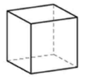
Rectangular Prism
Triangular Prism
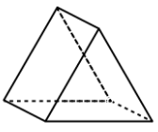
Square Pyramid
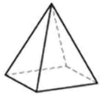
Cylinder
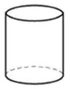
Sphere
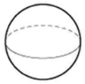
Cone
