Name:______________________________ Date:______________

The Travelers Tower Project

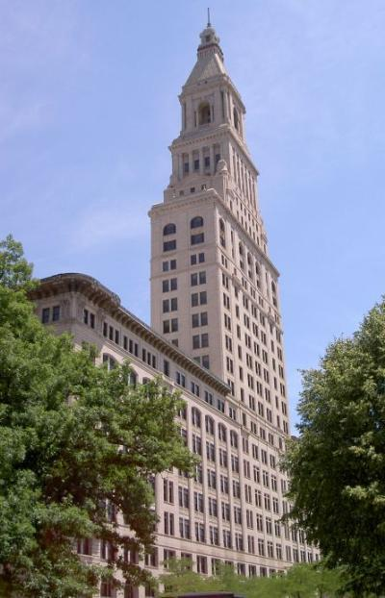
As one of the best mathematicians in the state of
Connecticut, the city of Hartford has recruited you to
help them in their pursuit to beautify one of their
oldest and most well known buildings – The Travelers
Tower. Use the information below and your prior
knowledge of 3-dimensional space figures to
complete the tasks assigned to you by the city planners.

Each part of the project will be worth 4 points. Before
turning in your project, refer to the rubric below. Make
sure all questions are answered completely, and all
work must be shown to get full credit!

Task #1 |  |  | Task #3
Volume of the Top |  |  | Name of the Solid
Volume of the Upper Level |  |  | Gallons of Paint
Volume of the Middle Level |  |  | Task #4
Volume of the Bottom Level |  |  | Cost for the Heating and Air Conditioning System
Total Volume |  |  | Cost for Cleaning
Task #2 |  |  | Cost of Painting
Surface Area of the Upper Level |  |  | Total Cost
Surface Area of the Middle Level
Surface Area of the Bottom Level
Total Surface Area

Width (all levels): 20 meters
Top slant height: 26 meters

Bottom Level length: 120 meters | Bottom Level height: 70 meters
Middle Level length: 30 meters | Middle Level height: 50 meters
Upper Level length: 20 meters | Upper Level height: 20 meters
Top length: 20 meters | Top height: 24 meters

Use this drawing to help you complete each task. It may be helpful to write in the corresponding measurements.

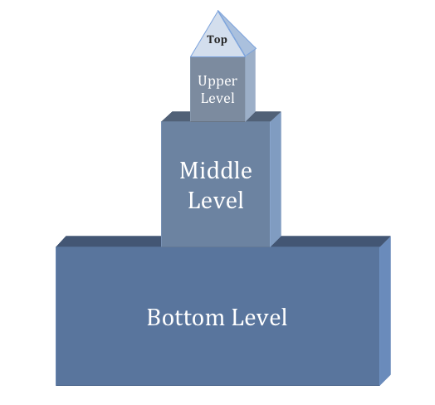

Your Tasks:

Task #1 – The planners want to put in a new heating and air conditioning system in the tower. In order to buy an appropriate size system, they need to know about how much space there is inside the building that will need to be heated or air conditioned. Calculate volumes of each level separately. Then calculate the total volume of the tower.

Task #2 – Since the Travelers building has been around for so many years, the city decided that every surface visible to the public needs to be cleaned (except for the very top which is going to get painted). The company they have hired for the job needs to know the amount of surface area that needs to be cleaned. Calculate the total visible surface area of the tower. Remember, only the visible surfaces. This does not include the sections where the levels overlap.

Task #3 – The very top of the Travelers building a familiar geometric solid.

Identify the name of the solid: ____________________________________

The city wants to paint the top of the tower gold to match the top of the state building. The paint that they plan on purchasing uses one gallon to cover an area of 30 square meters, how many gallons of gold paint will it take to cover the top of the Travelers Tower with 3 coats?

Task #4 – The city has decided to make you come up with the cost for all of the work on the tower. The cost for the new heating and air conditioning system is about $0.25 per cubic meter. The cost for cleaning 500 square meters of the tower is $300. The cost of a four gallon container of gold paint is $95. Calculate how much it will cost the city to beautify the Travelers Tower.

