Name: __________________________ Date: ___________
Spiral Review Quarter 2 Week 8 Calculator Active Period: _________

Answers

- ______________

- _______________

3) _______________

4) _______________

5) _______________

6) _______________

7) _______________

8) _______________

9) _______________

10) ______________

1.  54 + x = 9  2 | 2. $-22 = -5+ \frac{x}{2}$
3. Chris has $89.94, and he wants to order some DVD’s on-line that each cost $15.99. The total cost of shipping is $9.99. What is the solution set for how many DVDs Chris can buy? | 4. Graph the solution set  - (k – 5) ≤ -22
5. Solve  3(4 – 6x) - 7 < 41 | 6. Find the distance between Raleigh and Detroit if they are 43 cm apart on a map with a scale of 3 cm : 160 miles. (round to the nearest tenth)
7. The sporting goods store has a sale in which all soccer balls are 25% off the retail price. What is the sale price of a ball that has a retail price of $29? | 8. A house has a value of $150,000. After renovations, it now has a value of $175,000. What is the percent of change in the value of the house?
9. It takes a machine 21 minutes to fill 300 bottles. How long will it take the machine to fill 700 bottles? | 10. Find x  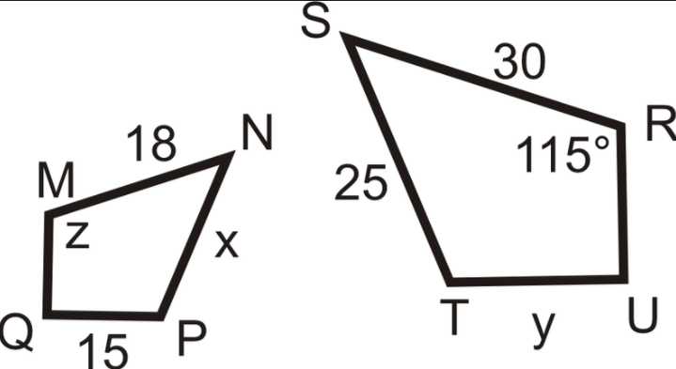

Weekly Warm-Up’s

Monday | Tuesday
Wednesday | Thursday
Friday | Important Information

