Cumulative Test Review Math 7/7+ Name___________________________
Date_________________

Solve each equation.
1. $\frac{m}{7}-9=-5$ 1.__________________

2. $12=4(b-2)$ 2.__________________

3. $m-3m+3=11$ 3.__________________

4. A waitress earned $73 for 6 hours of work. The total included $46 in tips. What was her hourly wage? 4.__________________

5. The length of a rectangle is 2 cm less than 7 times the width. The perimeter is 60 cm. Find the width and length. 5.__________________

6. $\frac{3}{2}\left(2x+4\right)=15$ 6.__________________

7. $4\left(y-9\right)=3\left(2y-8\right)$ 7.__________________

Solve each inequality. Graph the solutions on a number line.
8. $3<\frac{1}{2}x+1$ 8.__________________

9. $50<8-6x$ 9.__________________

10. $30≥-6\left(5-x\right)$ 10._________________

11. Negative 4 times a number minus 6 is at least 22. 11._________________

Use the table below to answer questions 12-13.
 | Boys | Girls
7th Grade | 26 | 34
8th Grade | 30 | 22

12. Write a ratio in simplest form of 7th graders to 8th graders. 12._________________

13. Write a ratio in simplest form of girls to all students. 13._________________

Find each unit rate.
14. 20 cups of water evaporates in 5 days. 14._________________

15. A car goes 425 miles on 12.5 gallons of gas. 15._________________

16. Three posters cost $9.60. At that rate, how many posters can you buy for $48? 16._________________

17. A rectangle that is 20 cm long and 28 cm wide is the same shape as one that is 9 cm long and z cm wide. Find z. 17._________________

18. Find x.
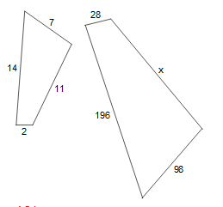 18._________________

19. A map scale is 1 in: 24 mi. About how far is it between two cities that are 3 in. apart on a map? 19._________________

20. Does the following graph represent a proportional relationship? If so, what is the constant of proportionality?
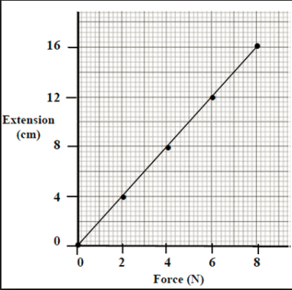
20._________________
Find the slope.
21. 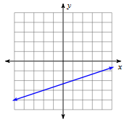 22. 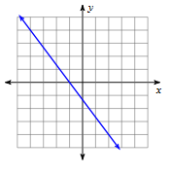 23. 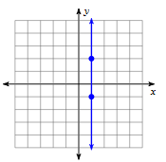

24. Identify the slope and y-intercept in the equation $y=\frac{-2}{3}x+4$. 24._________________

25. 120 is 15% of what number? 25._________________

26. What percent of 150 is 96? 26._________________

27. At Apex Middle School, 4.8% of the students chose hamburgers as their favorite school lunch. There are 1,500 students in the school. How many chose hamburgers? 27._________________

28. The average cost of a gallon of gas was $1.29 in 1997 and $1.12 in 1998. Find the percent of change. 28._________________

29. Athletic shoes that regularly sell for $85.99 are on sale for 20% off. Find the discount price. 29._________________

30. Macy works at an appliance store. She receives commission in addition to her hourly pay. She earns 3% commission on all of her sales. How much will she earn if her total sales were $8250? 30._________________

31. Suppose you want to buy three books that cost $6.95, $9.95, and $10.95. The bookstore is having a ¼ off sale. Your state charges sales tax of 5% of an item’s final price. You have $20. Do you have enough money? 31._________________
32. Matthew invests $5,000 at 14% simple interest. About how much interest will he earn in eight months? 32._________________

A savings account pays 4% simples interest.
33. How much interest does an $800 deposit earn in 4 years? 33._________________

34. How much more would the $800 earn in 4 years at 5%? 34._________________

Fill in the missing information in the table below.
 | Principal | Interest Rate | Time | Simple  Interest
35. | $200 |  | 2 years | $28
36. |  | 6% | 9 months | $39.15
35._________________

36._________________

