Zero and Negative Exponents
We’ve seen expressions with positive exponents, but what about having a zero or negative exponent?
Fill in the table below and look for a pattern to help you find $4^{0}$.
$4^{0}=$ ?
$$4^{4}$$
$$4^{3}$$
$$4^{2}$$
$$4^{1}$$
$$4^{0}$$
The Zero Exponent Property states that any nonzero base raised to the zero power
is equal to _______.
Zero Exponent Property
For any nonzero number a
$$a^{0}=1$$

Look at each expression and determine how to simplify the expression using the Zero Exponent Property.
$1. {\left(4.7\right)}^{0}=___________$ $2. {\left(-6\right)}^{0}=___________$ $3. -{\left(6\right)}^{0}=___________$

$4. {\left(3ab\right)}^{0}=___________$ $5. {3ab}^{0}=___________$

But why isn’t ${3ab}^{0}$ equal to 1?
Look carefully at what is being raised to the zero power. Without parentheses, the zero power only applies to base b so only $b^{0}$ is equal to 1. Therefore the expression simplifies to $3a$.
Simplify each expression.
$1. x^{0}=__________$ $2. {\left(-3.4\right)}^{0}=__________$

$3. {-6}^{0}=__________$ $4. 5xy^{0}=__________$

*******************Get your answers checked before moving on**********************
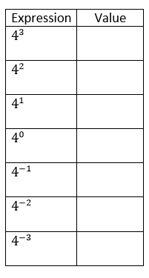
Recall the table previously used to find the value of $5^{0}$. Now let’s extend that table to look at negative exponents. Using the pattern of dividing, complete each table. Express your answers as fractions when necessary.
Expression | Value
$$5^{3}$$

$$5^{2}$$

$$5^{1}$$
$$5^{0}$$
$$5^{-1}$$
$$5^{-2}$$
$$5^{-3}$$

Did you notice a pattern for the negative exponents?
The Negative Exponent Property states that any nonzero base raised to a negative power can be written as one over the base to the opposite power.
Negative Exponent Property
For all numbers a and n where $a≠0$,
$$a^{-n}=\frac{1}{a^{n}}$$

Simplify each expression using positive exponents.

$1. x^{-5}y^{7}=__________$ $2. 4^{-2}m^{-11}=__________$ $3. 7^{-3}s^{13}y^{0}=__________$

$4. \frac{1}{a^{-3}}=__________$ $5. \frac{-8a^{-1}b}{c^{-5}}=__________$

